Internet

Internet is defined as an Information super Highway, to access information over the web. However, It can be defined in many ways as follows:

* Internet is a world-wide global system of interconnected computer networks.
* Internet uses the standard Internet Protocol (TCP/IP).
* Every computer in internet is identified by a unique IP address.
* IP Address is a unique set of numbers (such as 110.22.33.114) which identifies a computer location.
* A special computer DNS (Domain Name Server) is used to give name to the IP Address so that user can locate a computer by a name.
* For example, a DNS server will resolve a name **http://www.tutorialspoint.com** to a particular IP address to uniquely identify the computer on which this website is hosted.
* Internet is accessible to every user all over the world.

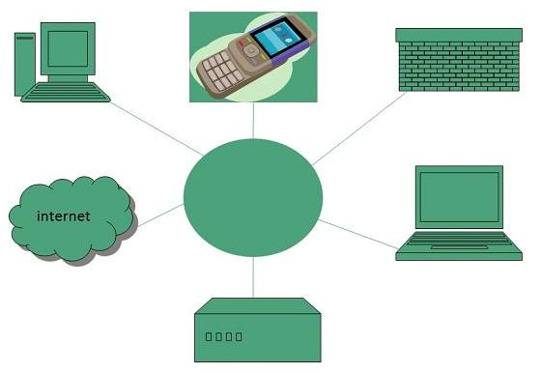

Evolution

The concept of Internet was originated in 1969 and has undergone several technological & Infrastructural changes as discussed below:

* The origin of Internet devised from the concept of **Advanced Research Project Agency Network (ARPANET).**
* **ARPANET** was developed by United States Department of Defense.
* Basic purpose of ARPANET was to provide communication among the various bodies of government.
* Initially, there were only four nodes, formally called **Hosts.**
* In 1972, the **ARPANET** spread over the globe with 23 nodes located at different countries and thus became known as **Internet.**
* By the time, with invention of new technologies such as TCP/IP protocols, DNS, WWW, browsers, scripting languages etc.,Internet provided a medium to publish and access information over the web.

Advantages

Internet covers almost every aspect of life, one can think of. Here, we will discuss some of the advantages of Internet:

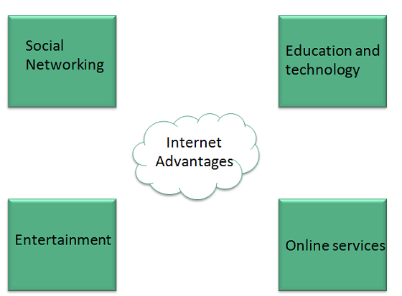

* Internet allows us to communicate with the people sitting at remote locations. There are various apps available on the wed that uses Internet as a medium for communication. One can find various social networking sites such as:
  + Facebook
  + Twitter
  + Yahoo
  + Google+
  + Flickr
  + Orkut
* One can surf for any kind of information over the internet. Information regarding various topics such as Technology, Health & Science, Social Studies, Geographical Information, Information Technology, Products etc can be surfed with help of a search engine.
* Apart from communication and source of information, internet also serves a medium for entertainment. Following are the various modes for entertainment over internet.
  + Online Television
  + Online Games
  + Songs
  + Videos
  + Social Networking Apps
* Internet allows us to use many services like:
  + Internet Banking
  + Matrimonial Services
  + Online Shopping
  + Online Ticket Booking
  + Online Bill Payment
  + Data Sharing
  + E-mail
* Internet provides concept of **electronic commerce**, that allows the business deals to be conducted on electronic systems

Disadvantages

However, Internet has prooved to be a powerful source of information in almost every field, yet there exists many disadvanatges discussed below:

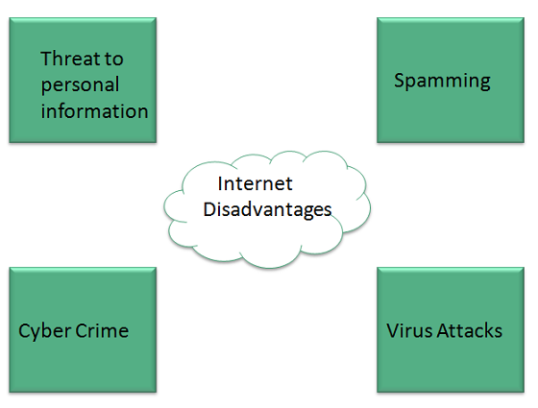

* There are always chances to loose personal information such as name, address, credit card number. Therefore, one should be very careful while sharing such information. One should use credit cards only through authenticated sites.
* Another disadvantage is the **Spamming**.Spamming corresponds to the unwanted e-mails in bulk. These e-mails serve no purpose and lead to obstruction of entire system.
* **Virus** can easily be spread to the computers connected to internet. Such virus attacks may cause your system to crash or your important data may get deleted.
* Also a biggest threat on internet is pornography. There are many pornographic sites that can be found, letting your children to use internet which indirectly affects the children healthy mental life.
* There are various websites that do not provide the authenticated information. This leads to misconception among many people.

## Intranet

Intranet is defined as private network of computers within an organization with its own server and firewall. Moreover we can define Intranet as:

* Intranet is system in which multiple PCs are networked to be connected to each other. PCs in intranet are not available to the world outside of the intranet.
* Usually each company or organization has their own Intranet network and members/employees of that company can access the computers in their intranet.
* Every computer in internet is identified by a unique IP address.
* Each computer in Intranet is also identified by a IP Address, which is unique among the computers in that Intranet.

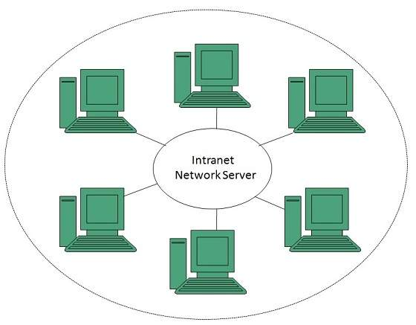

## Benefits

Intranet is very efficient and reliable network system for any organization. It is beneficial in every aspect such as collaboration, cost-effectiveness, security, productivity and much more.

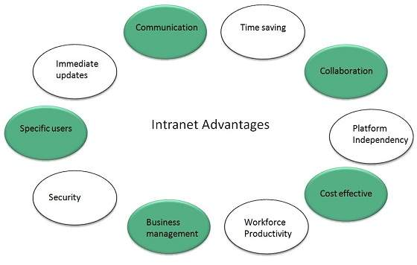

### **Communication**

Intranet offers easy and cheap communication within an organization. Employees can communicate using chat, e-mail or blogs.

### **Time Saving**

Information on Intranet is shared in real time.

### **Collaboration**

Information is distributed among the employees as according to requirement and it can be accessed by the authorized users, resulting in enhanced teamwork.

### **Platform Independency**

Intranet can connect computers and other devices with different architecture.

### **Cost Effective**

Employees can see the data and other documents using browser rather than printing them and distributing duplicate copies among the employees, which certainly decreases the cost.

### **Workforce Productivity**

Data is available at every time and can be accessed using company workstation. This helps the employees work faster.

### **Business Management**

It is also possible to deploy applications that support business operations.

### **Security**

Since information shared on intranet can only be accessed within an organization, therefore there is almost no chance of being theft.

### **Specific Users**

Intranet targets only specific users within an organization therefore, once can exactly know whom he is interacting.

### **Immediate Updates**

Any changes made to information are reflected immediately to all the users.

## Issues

Apart from several benefits of Intranet, there also exist some issues.. These issues are shown in the following diagram:

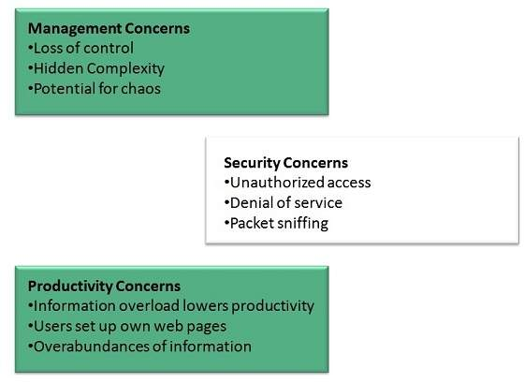

## Applications

Intranet applications are same as that of Internet applications. Intranet applications are also accessed through a web browser. The only difference is that, Intranet applications reside on local server while Internet applications reside on remote server. Here, we've discussed some of these applications:

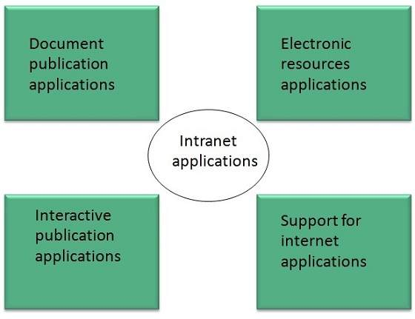

### **Document publication applications**

Document publication applications allow publishing documents such as manuals, software guide, employee profits etc without use of paper.

### **Electronic resources applications**

It offers electronic resources such as software applications, templates and tools, to be shared across the network.

### **Interactive Communication applications**

Like on internet, we have e-mail and chat like applications for Intranet, hence offering an interactive communication among employees.

### **Support for Internet Applications**

Intranet offers an environment to deploy and test applications before placing them on Internet.

## Internet vs. Intranet

Apart from similarities there are some differences between the two. Following are the differences between Internet and Intranet:

|  |  |
| --- | --- |
| **Intranet** | **Internet** |
| Localized Network. | Worldwide Network |
| Doesn't have access to Intranet | Have access to Internet. |
| More Expensive | Less Expensive |
| More Safe | Less Safe |
| More Reliability | Less Reliability |

## Extranet

Extranet refers to network within an organization, using internet to connect to the outsiders in controlled manner. It helps to connect businesses with their customers and suppliers and therefore allows working in a collaborative manner.

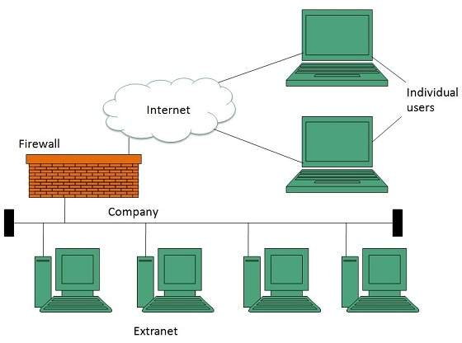

### **Implementation**

Extranet is implemented as a Virtual Private Networks (VPN) because it uses internet to connect to corporate organization and there is always a threat to information security. VPN offers a secure network in public infrastructure (Internet).

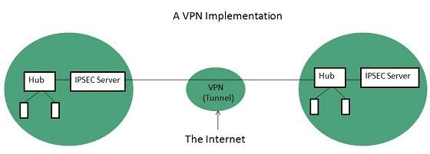

**Key Points**

* The packet is encapsulated at boundary of networks in IPSEC complaint routers.
* It uses an encryption key to encapsulate packets and IP addresses as well.
* The packet is decoded only by the IPSEC complaint routers or servers.
* The message is sent over VPN via VPN Tunnel and this process is known as tunneling.

VPN uses **Internet Protocol Security Architecture (IPSEC)** Protocol to provide secure transactions by adding an additional security layer to TCP/IP protocol. This layer is created by encapsulating the IP packet to a new IP packet as shown in the following diagram:

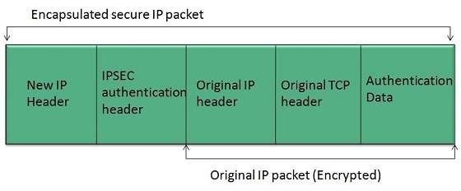

## Benefits

Extranet proves to be a successful model for all kind of businesses whether small or big. Here are some of the advantages of extranet for employees, suppliers, business partners, and customers:

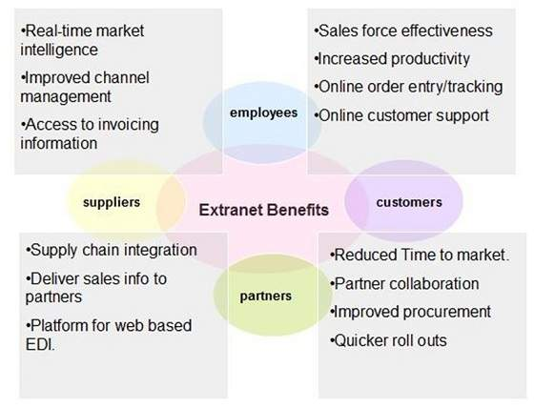

## Issues

Apart for advantages there are also some issues associated with extranet. These issues are discussed below:

### **Hosting**

Where the extranet pages will be held i.e. who will host the extranet pages. In this context there are two choices:

* Host it on your own server.
* Host it with an Internet Service Provider (ISP) in the same way as web pages.

But hosting extranet pages on your own server requires high bandwidth internet connection which is very costly.

### **Security**

Additional firewall security is required if you host extranet pages on your own server which result in a complex security mechanism and increase work load.

### **Accessing Issues**

Information can not be accessed without internet connection. However, information can be accessed in Intranet without internet connection.

### **Decreased Interaction**

It decreases the face to face interaction in the business which results in lack of communication among customers, business partners and suppliers.

## Extranet vs. Intranet

The following table shows differences between Extranet and Intranet:

|  |  |
| --- | --- |
| **Extranet** | **Intranet** |
| Internal network that can be accessed externally. | Internal network that can not be accessed externally. |
| Extranet is extension of company's Intranet. | Only limited users of a company. |
| For limited external communication between customers, suppliers and business partners. | Only for communication within a company. |

## Overview

When **DNS** was not into existence, one had to download a **Host file** containing host names and their corresponding IP address. But with increase in number of hosts of internet, the size of host file also increased. This resulted in increased traffic on downloading this file. To solve this problem the DNS system was introduced.

**Domain Name System** helps to resolve the host name to an address. It uses a hierarchical naming scheme and distributed database of IP addresses and associated names

## IP Address

IP address is a unique logical address assigned to a machine over the network. An IP address exhibits the following properties:

* IP address is the unique address assigned to each host present on Internet.
* IP address is 32 bits (4 bytes) long.
* IP address consists of two components:**network component** and **host component**.
* Each of the 4 bytes is represented by a number from 0 to 255, separated with dots. For example 137.170.4.124

IP address is 32-bit number while on the other hand domain names are easy to remember names. For example, when we enter an email address we always enter a symbolic string such as webmaster@tutorialspoint.com.

## Uniform Resource Locator (URL)

**Uniform Resource Locator (URL)** refers to a web address which uniquely identifies a document over the internet.

This document can be a web page, image, audio, video or anything else present on the web.

For example, **www.tutorialspoint.com/internet_technology/index.html** is an URL to the index.html which is stored on tutorialspoint web server under internet_technology directory.

### **URL Types**

There are two forms of URL as listed below:

* Absolute URL
* Relative URL

#### **Absolute URL**

Absolute URL is a complete address of a resource on the web. This completed address comprises of protocol used, server name, path name and file name.

For example http:// www.tutorialspoint.com / internet_technology /index.htm. where:

* **http** is the protocol.
* **tutorialspoint.com** is the server name.
* **index.htm** is the file name.

The protocol part tells the web browser how to handle the file. Similarly we have some other protocols also that can be used to create URL are:

* FTP
* https
* Gopher
* mailto
* news

#### **Relative URL**

Relative URL is a partial address of a webpage. Unlike absolute URL, the protocol and server part are omitted from relative URL.

Relative URLs are used for internal links i.e. to create links to file that are part of same website as the WebPages on which you are placing the link.

For example, to link an image on tutorialspoint.com/internet_technology/internet_referemce_models, we can use the relative URL which can take the form like **/internet_technologies/internet-osi_model.jpg.**

### **Difference between Absolute and Relative URL**

|  |  |
| --- | --- |
| **Absolute URL** | **Relative URL** |
| Used to link web pages on different websites | Used to link web pages within the same website. |
| Difficult to manage. | Easy to Manage |
| Changes when the server name or directory name changes | Remains same even of we change the server name or directory name. |
| Take time to access | Comparatively faster to access. |

## Domain Name System Architecture

The Domain name system comprises of **Domain Names, Domain Name Space, Name Server** that have been described below:

### **Domain Names**

Domain Name is a symbolic string associated with an IP address. There are several domain names available; some of them are generic such as **com, edu, gov, net** etc, while some country level domain names such as **au, in, za, us** etc.

The following table shows the **Generic** Top-Level Domain names:

|  |
| --- |
|  |
| **Domain Name** | **Meaning** |
| Com | Commercial business |
| Edu | Education |
| Gov | U.S. government agency |
| Int | International entity |
| Mil | U.S. military |
| Net | Networking organization |
| Org | Non profit organization |

The following table shows the **Country top-level** domain names:

|  |
| --- |
|  |
| **Domain Name** | **Meaning** |
| au | Australia |
| in | India |
| cl | Chile |
| fr | France |
| us | United States |
| za | South Africa |
| uk | United Kingdom |
| jp | Japan |
| es | Spain |
| de | Germany |
| ca | Canada |
| ee | Estonia |
| hk | Hong Kong |

### **Domain Name Space**

The domain name space refers a hierarchy in the internet naming structure. This hierarchy has multiple levels (from 0 to 127), with a root at the top. The following diagram shows the domain name space hierarchy:

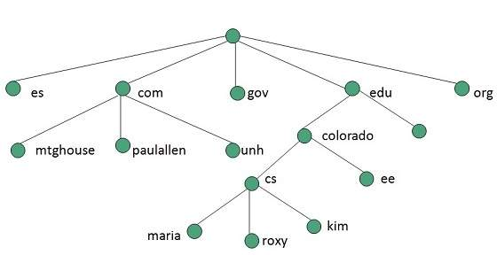

In the above diagram each subtree represents a domain. Each domain can be partitioned into sub domains and these can be further partitioned and so on.

### **Name Server**

Name server contains the DNS database. This database comprises of various names and their corresponding IP addresses. Since it is not possible for a single server to maintain entire DNS database, therefore, the information is distributed among many DNS servers.

* Hierarchy of server is same as hierarchy of names.
* The entire name space is divided into the zones

### **Zones**

Zone is collection of nodes (sub domains) under the main domain. The server maintains a database called zone file for every zone.

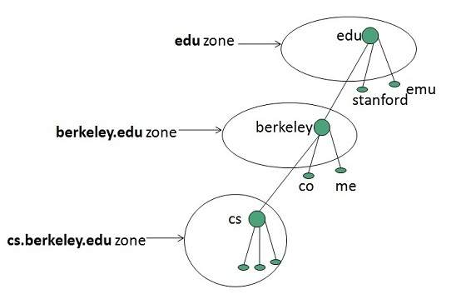

If the domain is not further divided into sub domains then domain and zone refers to the same thing.

The information about the nodes in the sub domain is stored in the servers at the lower levels however; the original server keeps reference to these lower levels of servers.

#### **Types of Name Servers**

Following are the three categories of Name Servers that manages the entire Domain Name System:

* Root Server
* Primary Server
* Secondary Server

##### **Root Server**

Root Server is the top level server which consists of the entire DNS tree. It does not contain the information about domains but delegates the authority to the other server

##### **Primary Servers**

Primary Server stores a file about its zone. It has authority to create, maintain, and update the zone file.

##### **Secondary Server**

Secondary Server transfers complete information about a zone from another server which may be primary or secondary server. The secondary server does not have authority to create or update a zone file.

## DNS Working

DNS translates the domain name into IP address automatically. Following steps will take you through the steps included in domain resolution process:

* When we type **www.tutorialspoint.com** into the browser, it asks the local DNS Server for its IP address.

Here the local DNS is at ISP end.

* When the local DNS does not find the IP address of requested domain name, it forwards the request to the root DNS server and again enquires about IP address of it.
* The root DNS server replies with delegation that **I do not know the IP address of www.tutorialspoint.com but know the IP address of DNS Server.**
* The local DNS server then asks the com DNS Server the same question.
* The **com** DNS Server replies the same that it does not know the IP address of www.tutorialspont.com but knows the address of tutorialspoint.com.
* Then the local DNS asks the tutorialspoint.com DNS server the same question.
* Then tutorialspoint.com DNS server replies with IP address of www.tutorialspoint.com.
* Now, the local DNS sends the IP address of www.tutorialspoint.com to the computer that sends the request.

# Structure of a Client Server System

[Computer Engineering](https://www.tutorialspoint.com/questions/category/Computer-Engineering)[MCA](https://www.tutorialspoint.com/questions/category/MCA)[Operating System](https://www.tutorialspoint.com/questions/category/Operating-System)

In client server computing, the clients requests a resource and the server provides that resource. A server may serve multiple clients at the same time while a client is in contact with only one server.

The different structures for two tier and three tier are given as follows −

## Two - Tier Client/Server Structure

The two tier architecture primarily has two parts, a client tier and a server tier.The client tier sends a request to the server tier and the server tier responds with the desired information.

An example of a two tier client/server structure is a web server. It returns the required web pages to the clients that requested them.

An illustration of the two-tier client/server structure is as follows −

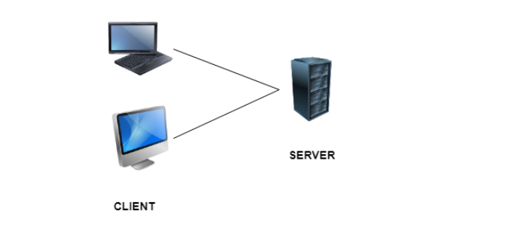

### Advantages of Two - Tier Client/Server Structure

Some of the advantages of the two-tier client/server structure are −

* This structure is quite easy to maintain and modify.
* The communication between the client and server in the form of request response messages is quite fast.

### Disadvantages of Two - Tier Client/Server Structure

A major disadvantage of the two-tier client/server structure is −

* If the client nodes are increased beyond capacity in the structure, then the server is not able to handle the request overflow and performance of the system degrades.

## Three - Tier Client/Server Structure

The three tier architecture has three layers namely client, application and data layer. The client layer is the one that requests the information. In this case it could be the GUI, web interface etc. The application layer acts as an interface between the client and data layer. It helps in communication and also provides security. The data layer is the one that actually contains the required data.

An illustration of the three-tier client/server structure is as follows −

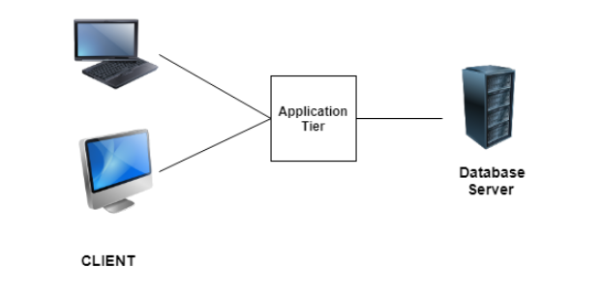

### Advantages of Three - Tier Client/Server Structure

Some of the advantages of the three-tier client/server structure are −

* The three tier structure provides much better service and fast performance.
* The structure can be scaled according to requirements without any problem.
* Data security is much improved in the three tier structure.

### Disadvantages of Three - Tier Client/Server Structure

A major disadvantage of the three-tier client/server structure is −

* Three - tier client/server structure is quite complex due to advanced features.

# **Web - Domain Names**

Advertisements

[Previous Page](https://www.tutorialspoint.com/web_developers_guide/web_tools_required.htm)

[Next Page](https://www.tutorialspoint.com/web_developers_guide/web_site_construction.htm)

A domain name is the part of your Internet address that comes after "www". For example, in [Tutorialspoint.com](http://www.tutorialspoint.com/) the domain name is tutorialspoint.com.

A domain name becomes your Business Address so care should be taken to select a domain name. Your domain name should be easy to remember and easy to type.

## How to Get a Domain Name?

When you plan to put a site online, this is one of the important steps to buy a domain name. This is always not necessary that whatever domain name you are looking that is available so in that case you will have to opt for any other good domain name.

When you buy a domain name it is registered and when domain names are registered they are added to a large domain name register, and information about your site − including your Internet IP address is stored on a DNS server and your contact information etc. is registered with your registrar.

You can buy domain name from any domain registrar like [GoDaddy](http://www.godaddy.com/)

## Domain Extension Types

There are many types of domain extensions you can choose for your domain name. This depends on your business nature.

For example, if you are going to register a domain name for education purpose then you can choose ***.edu*** extension.

Below is a reference of the correct usage of certain extensions. But there is no hard and fast rule to go for any extension. Most commonly used is ***.com***

* **.com** − Stands for company/commercial, but it can be used for any website.
* **.net** − Stands for network and is usually used for a network of sites.
* **.org** − Stands for organization and is supposed to be for non-profit bodies.
* **.us, .in** − They are based on your country names so that you can go for country specific domain extensions
* **.biz** − A newer extension on the Internet and can be used to indicate that this site is purely related to business.
* **.info** − Stands for information. This domain name extension can be very useful, and as a new comer it's doing well.
* **.tv** − Stands for Television and are more appropriate for TV channel sites.

Newer domain extensions such as .biz .info and .us etc. have more name choices available as many of the popular domains have yet to be taken and most of the them are available at very nominal prices.

## Choosing a Domain Name

The domain name will be your business address. Hence, it is imperative that you choose the domain name with utmost care.

Many people think it is important to have keywords in a domain. Keywords in the domain name are usually important, but it usually can be done while keeping the domain name short, memorable, and free of hyphens.

Using keywords in your domain name gives you a strong competitive advantage over your competitors. Having your keywords in your domain name can increase click through rates on search engine listings and paid ads as well as make it easier to using your keywords in get keyword rich descriptive inbound links.

Avoid buying long and confusing domain names. May people separate the words in their domain names using dashes or hyphen. In the past the domain name itself was a significant ranking factor but now with advanced search engines, it is not a significant factor anymore.

Keep two to three words in your domain name − it will be more memorable. Some of the most memorable websites do a great job of branding by creating their own words. Examples include eBay, Yahoo!, Expedia, Slashdot, Fark, Wikipedia, Google...

You should be able to say it over the telephone once and the other person should know how to spell it and they should know what you sell. If you can do that AND work keywords in there, good for you. If you can't, skip the keywords.

## What are Sub-Domains

You can divide your domain into many sub domains based on your requirement. If you are doing multiple business using the same domain, then it would be useful to have sub-domains for every business. Following are examples of some sub-domains −

You must have seen [*google.com*](http://www.google.com/) as a main domain but google has created many subdomains based on their business. Some of them are as follows −

* [*adwords.google.com*](http://adwords.google.com/) − This sub domain is being used for Google Adwords.
* [*groups.google.com*](http://groups.google.com/) − This sub domain is being used for Google Groups.
* [*images.google.com*](http://images.google.com/) − This sub domain is being used for Google Images.

This way, you can present your different business sections in a very good segregated way. It is not a big thing to create a sub-domains. If you already have registered a domain, then your registrar will provide you a way to create sub-domains. You may need to talk to your registrar for more detail.